Combinational Logic

- Goal – Represent the hardware design flow and the basic gates.
- Learning outcome - by the end of this class the students should distinguish different levels of hardware design, should know the place of the gate level in the flow, should know the main gates and how they could be opened or closed.

Basic Logical Functions and Gates

While each logical element or condition must always have a logic value of either "0" or "1", we also need to have ways to combine different logical signals or conditions to provide a logical result.

For example, consider the logical statement: "If I move the switch on the wall up, the light will turn on." At first glance, this seems to be a correct statement. However, if we look at a few other factors, we realize that there's more to it than this. In this example, a more complete statement would be: "If I move the switch on the wall up and the light bulb is good and the power is on, the light will turn on."

If we look at these two statements as logical expressions and use logical terminology, we can reduce the first statement to:

Light = Switch

This means nothing more than that the light will follow the action of the switch, so that when the switch is up/on/true/1 the light will also be on/true/1. Conversely, if the switch is down/off/false/0 the light will also be off/false/0.

Looking at the second version of the statement, we have a slightly more complex expression:

Light = Switch and Bulb and Power

Normally, we use symbols rather than words to designate the and function that we're using to combine the separate variables of Switch, Bulb, and Power in this expression. The symbol normally used is a dot, which is the same symbol used for multiplication in some mathematical expressions. Using this symbol, our three-variable expression becomes:

Light = Switch Bulb Power

When we deal with logical circuits (as in computers), we not only need to deal with logical functions; we also need some special symbols to denote these functions in a logical diagram.

There are three fundamental logical operations, from which all other functions, no matter how complex, can be derived.
These functions are named and, or, and not.
Each of these has a specific symbol and a clearly-defined behavior.

Logic Gates

Electronic circuits which combine digital signals according to the Boolean algebra are referred to as logic gates; gates because they control the flow of information. Positive logic is an electronic representation in which the true state is at a higher voltage, while negative logic has the true state at a lower voltage. We will use the positive logic type in this course.

In digital circuits all inputs must be connected.

The AND Gate

The AND gate implements the AND function. With the gate shown to the left, both inputs must have logic 1 signals applied to them in order for the output to be a logic 1. With either input at logic 0, the output will be held to logic 0.

There is no limit to the number of inputs that may be applied to an AND function, so there is no functional limit to the number of inputs an AND gate may have. However, for practical reasons, commercial AND gates are most commonly manufactured with 2, 3, or 4 inputs.

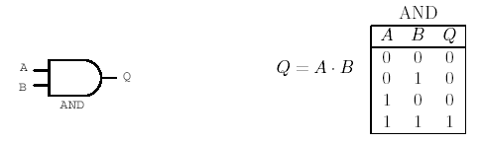

The OR Gate

The OR gate is sort of the reverse of the AND gate. The OR function, like its verbal counterpart, allows the output to be true (logic 1) if any one or more of its inputs are true. Verbally, we might say, "If it is raining OR if I turn on the sprinkler, the lawn will be wet." Note that the lawn will still be wet if the sprinkler is on and it is also raining. This is correctly reflected by the basic OR function.
In symbols, the OR function is designated with a plus sign (+). In logical diagrams, the symbol to the left designates the OR gate.
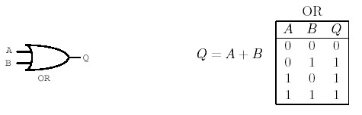
As with the AND function, the OR function can have any number of inputs. However, practical commercial OR gates are mostly limited to 2, 3, and 4 inputs, as with AND gates

How the gates work?

Besides implementing of the logical AND, OR functions the above mentioned devices have also “gate” functions.
How the gate function is implemented on the gates shown above ?

With each of these types the “gate” function works differently depended on the particular function.

There is a status of OPEN or CLOSE for the gate.
When the gate is OPEN then the logical value of the input (signal) can pass to the output of the gate.
When the gate is Closed then the logical value of the input (signal) can not pass to the output of the gate.
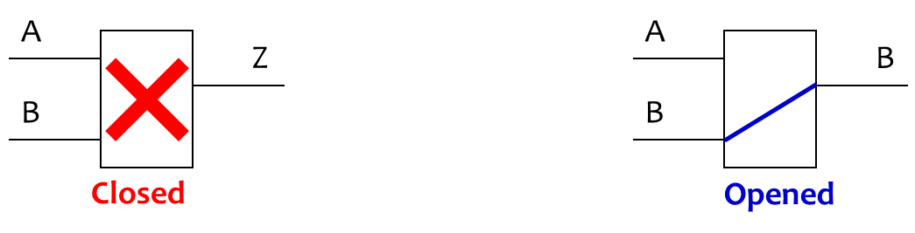
To force the device to work as a gate we have to satisfy the input conditions.

- For the AND gate the logical value 1 of one of the inputs of the gate allows the other input’s value to pass to the output.
- The output of the AND gate will be always 0 if one of the inputs we keep = 0.
- The input which we intentionally keep in 0 or 1 condition we call the control input.
- The other input which is passed or not to the output we call the data input.

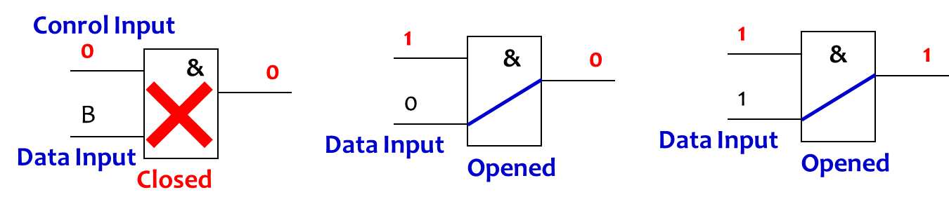

For the OR gate the control input should be 0 to allow the data input to pass to the output.
If we keep the control input =1 then the OR gate will be closed keeping the output value stable 1.

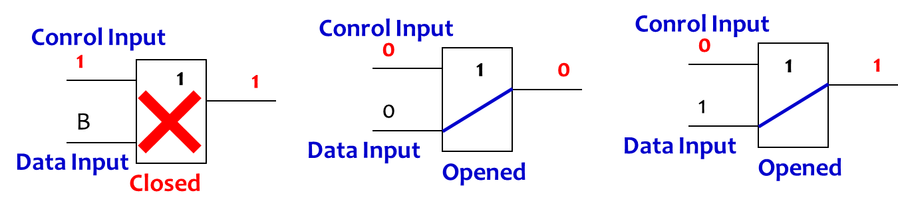

The NOT Gate, or Inverter

The inverter is a little different from AND and OR gates in that it always has exactly one input as well as one output. Whatever logical state is applied to the input, the opposite state will appear at the output.
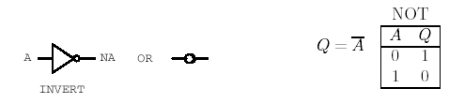

The NOT function, as it is called, is necessary in many applications and highly useful in others.

The NOT function is denoted by a horizontal bar over the value to be inverted, as shown in the figure to the left. In some cases a single quote mark (') may also be used for this purpose: 0' = 1 and 1' = 0. For greater clarity in some logical expressions, we will use the overbar most of the time.

In the inverter symbol, the triangle actually denotes only an amplifier, which in digital terms means that it "cleans up" the signal but does not change its logical sense. It is the circle at the output which denotes the logical inversion. The circle could have been placed at the input instead, and the logical meaning would still be the same.

The logic gates shown above are used in various combinations to perform tasks of any level of complexity. Some functions are so commonly used that they have been given symbols of their own, and are often packaged so as to provide that specific function directly. On the next page, we'll begin our coverage of these functions.

Derived Logical Functions and Gates

While the three basic functions AND, OR, and NOT are sufficient to accomplish all possible logical functions and operations, some combinations are used so commonly that they have been given names and logic symbols of their own:
NAND, NOR, XOR.

We will discuss three of these on this page. The first is called NAND, and consists of an AND function followed by a NOT function.
The second, as you might expect, is called NOR. This is an OR function followed by NOT.
The third is a variation of the OR function, called the Exclusive-OR, or XOR function.

As with the three basic logic functions, each of these derived functions has a specific logic symbol and behavior, which we can summarize as follows:

The NAND Gate

The NAND gate implements the NAND function, which is exactly inverted from the AND function you already examined. With the gate shown to the left, both inputs must have logic 1 signals applied to them in order for the output to be a logic 0. With either input at logic 0, the output will be held to logic 1.
The circle at the output of the NAND gate denotes the logical inversion, just as it did at the output of the inverter.
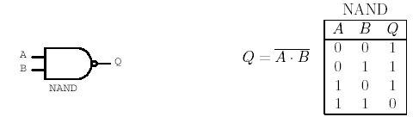
As with AND, there is no limit to the number of inputs that may be applied to a NAND function, so there is no functional limit to the number of inputs a NAND gate may have. However, for practical reasons, commercial NAND gates are most commonly manufactured with 2, 3, or 4 inputs, to fit in a 14-pin or 16-pin package.

The NOR Gate

The NOR gate is an OR gate with the output inverted. Where the OR gate allows the output to be true (logic 1) if any one or more of its inputs are true, the NOR gate inverts this and forces the output to logic 0 when any input is true.

In symbols, the NOR function is designated with a plus sign (+), with an overbar over the entire expression to indicate the inversion. In logical diagrams, the symbol to the left designates the NOR gate. As expected, this is an OR gate with a circle to designate the inversion.

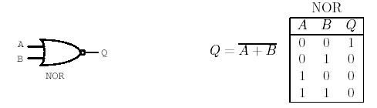
The NOR function can have any number of inputs, but practical commercial NOR gates are mostly limited to 2, 3, and 4 inputs, as with other gates in this class, to fit in standard IC packages.

The Exclusive-OR, or XOR Gate

The Exclusive-OR, or XOR function is an interesting and useful variation on the basic OR function. Verbally, it can be stated as, "Either A or B, but not both." The XOR gate produces a logic 1 output only if its two inputs are different. If the inputs are the same, the output is a logic 0.

The XOR symbol is a variation on the standard OR symbol. It consists of a plus (+) sign with a circle around it. The logic symbol, as shown here, is a variation on the standard OR symbol.
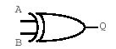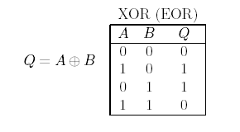

Unlike standard OR/NOR and AND/NAND functions, the XOR function always has exactly two inputs, and commercially manufactured XOR gates are the same. Four XOR gates fit in a standard 14-pin IC package.

The three derived functions shown above are by no means the only ones, but these form the basis of all the others. On the next page we will look at how the XOR function is derived. Then we will begin our look at practical applications for logic gates in various combinations, to see just how these simple gates can be combined to perform every possible operation in a computer.

Combinational and sequential logic circuits.

There are many ways in which the simple logic gates we have examined can be combined to perform useful functions.
Logic circuits are classified into two types, “combinational” and “sequential.”

Some of these circuits produce outputs which are only dependent upon the current logic states of all inputs. These are called combinational logic circuits.
A combinational logic circuit is one whose outputs depend only on its current inputs.

Other circuits are designed to actually remember the past states of their inputs, and to produce outputs based on those past signals as well as the current states of their inputs.
The outputs of a sequential logic circuit depend not only on the current inputs but also on the past sequence of inputs, possibly arbitrarily far back in time.

These circuits can act in accordance with a sequence of input signals, and are therefore known as sequential logic circuits.

combinational logic circuits – don’t have memory, are very fast

sequential logic circuits- have memory, are slow

Typical Hardware Design Flow

Design Specification

Behavioral Description

RTL(Register Transfer Level) Description

Logical Design
Functional Verification and Testing

Logic Synthesis

Gate-Level Netlist

Logical Verification and Testing

Floor Planning
Automatic Place & Route

Physical Design

Physical Layout

Layout Verification

Implementation
(CHIP)

Light boxes – Procedures
Dark Boxes – Design results in some form – description, file, database to be processed further to get the product (Chip).

